
http://ids-adi.org

POSC Caesar – FIATECH
Intelligent Data Sets - Accelerating Deployment of ISO15926
Realizing Open Information Interoperability

Mapping Editor Document
Version 1.1

Revision History
Document Version # | Action Taken, Notes | Date | Name
1.1 | Second release | 24 Sep, 2009 | Pavan Dubey

Terms of License
Copyright (c) 2009, ids-adi.org
All rights reserved.

Redistribution and use in source and binary forms, with or without
modification, are permitted provided that the following conditions are met:
* Redistributions of source code must retain the above copyright
notice, this list of conditions and the following disclaimer.
* Redistributions in binary form must reproduce the above copyright
notice, this list of conditions and the following disclaimer in the
documentation and/or other materials provided with the distribution.
* Neither the name of the ids-adi.org nor the
names of its contributors may be used to endorse or promote products
derived from this software without specific prior written permission.

THIS DOCUMENT IS PROVIDED BY ids-adi.org ''AS IS'' AND ANY
EXPRESS OR IMPLIED WARRANTIES, INCLUDING, BUT NOT LIMITED TO, THE IMPLIED
WARRANTIES OF MERCHANTABILITY AND FITNESS FOR A PARTICULAR PURPOSE ARE
DISCLAIMED. IN NO EVENT SHALL ids-adi.org BE LIABLE FOR ANY
DIRECT, INDIRECT, INCIDENTAL, SPECIAL, EXEMPLARY, OR CONSEQUENTIAL DAMAGES
(INCLUDING, BUT NOT LIMITED TO, PROCUREMENT OF SUBSTITUTE GOODS OR SERVICES;
LOSS OF USE, DATA, OR PROFITS; OR BUSINESS INTERRUPTION) HOWEVER CAUSED AND
ON ANY THEORY OF LIABILITY, WHETHER IN CONTRACT, STRICT LIABILITY, OR TORT
(INCLUDING NEGLIGENCE OR OTHERWISE) ARISING IN ANY WAY OUT OF THE USE OF THIS
SOFTWARE, EVEN IF ADVISED OF THE POSSIBILITY OF SUCH DAMAGE.
Table of Contents

POSC Caesar – FIATECH Intelligent Data Sets - Accelerating Deployment of ISO15926 Realizing Open Information Interoperability 1
Mapping Editor Document 1
1.0 Layout of Mapping Editor Homepage 4
2.0 Search Process 5
3.0 Mapping process 9

Layout of Mapping Editor Homepage
Mapping Editor home page has following components:
- A pane on the left top for Data Objects
- A pane on the right top for Information Model
- A pane on left bottom for showing details for whatever is selected from Data Objects pane, Information Model pane or Mapping pane.
- A pane on right bottom for Mapping, showing data from Mapping.xml

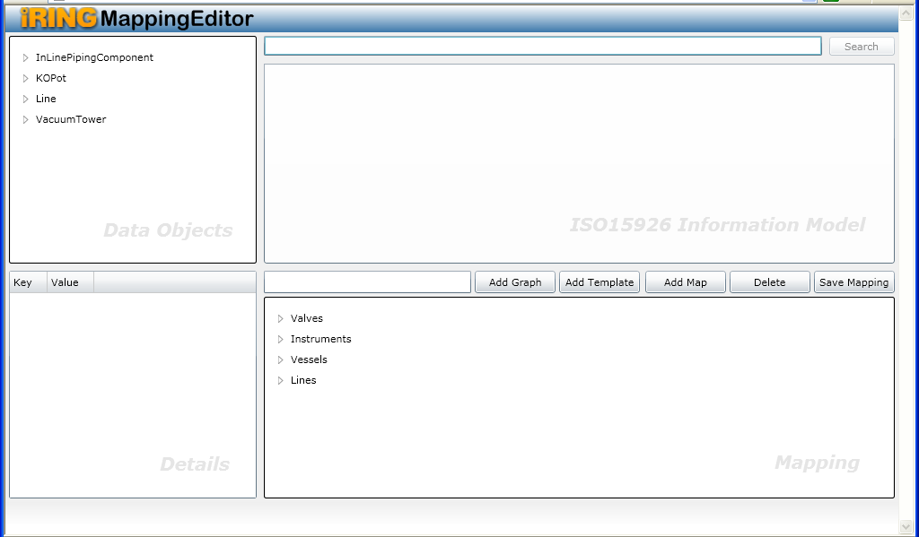

User can also perform following operation on Mapping Editor homepage

- Search: for searching data from all available endpoints
- Add Graph: for adding a graph in Mapping pane
- Add Template: for adding a template in Mapping pane
- Add Map: for performing map
- Delete: for deleting any node from mapping
- Save Mapping: for saving mapping.xml with the information added in Mapping pane

Search Process

- User can search for any class by entering search criterion in search field in Information Model. Based on search criterion; the information model pane displays results. On doing search a new tab appears as below

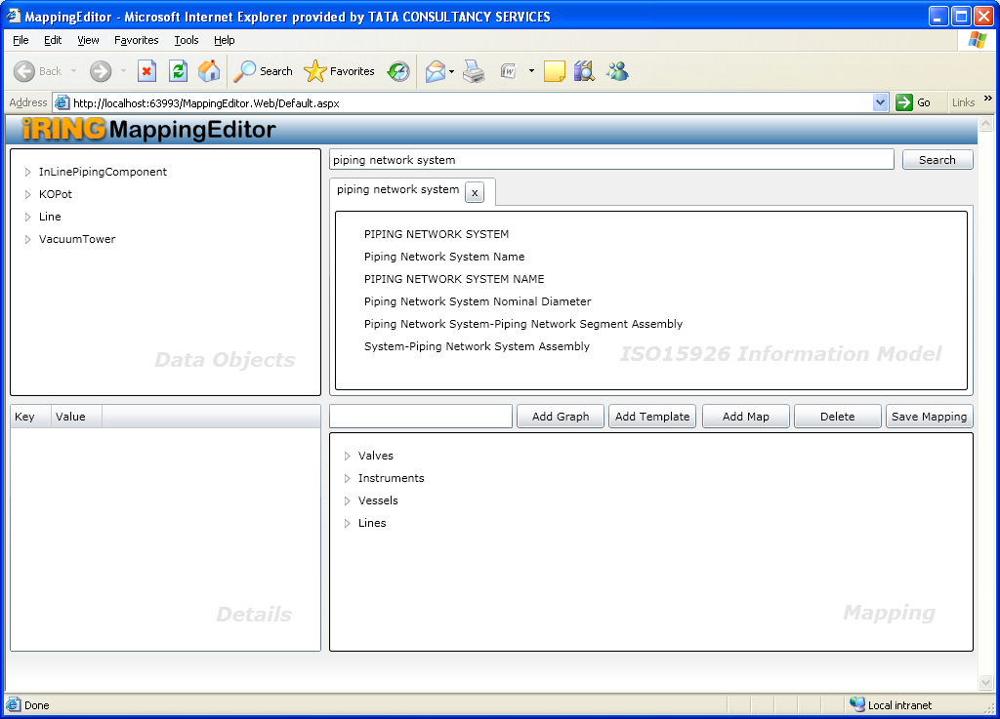

- For each search a new tab appears like following

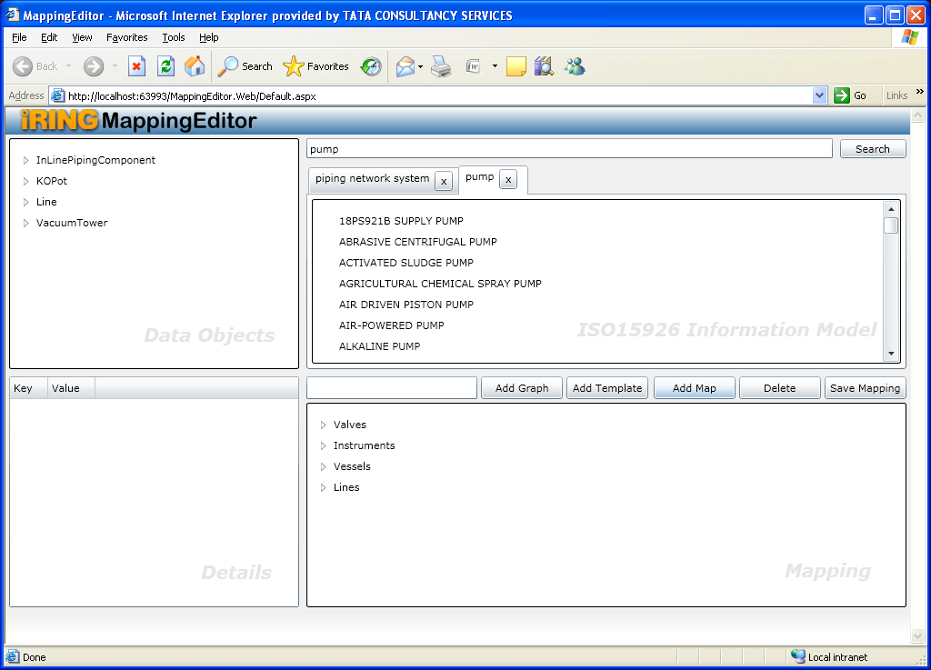

- Upon selection of any item from search results four new templates (Classifications, Super Class, Sub Classes and Templates) are added to the selected items. Like following

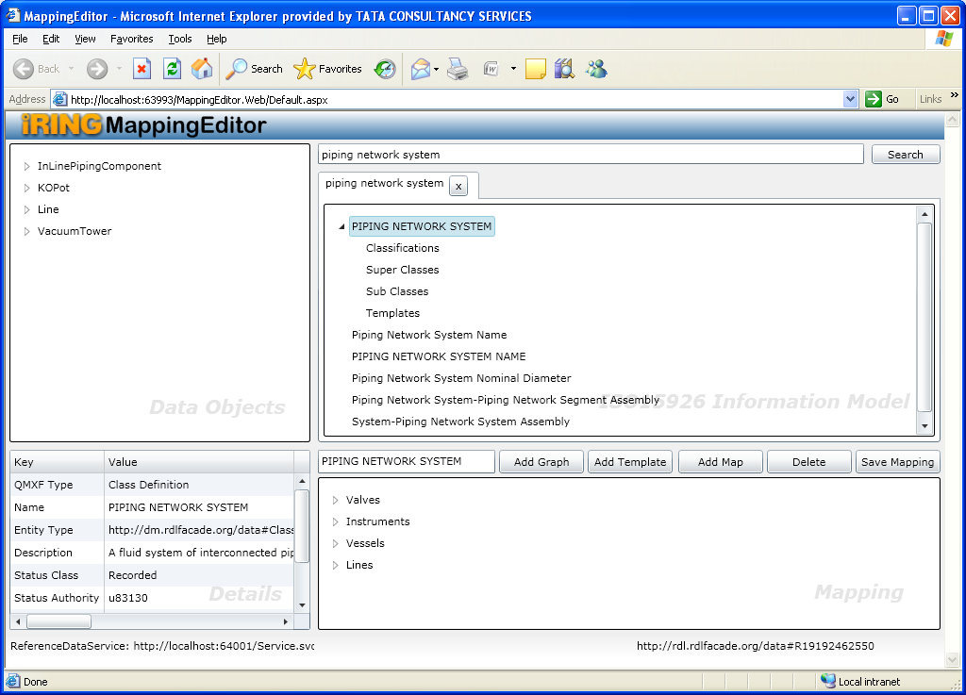

Classifications template will show the “Is Member of” type classes of selected item,
Super Classes template will show the all immediate super classes of selected item,
Sub Classes template will show all immediate sub classes of selected item,
Templates template will show all related templates related to selected class.

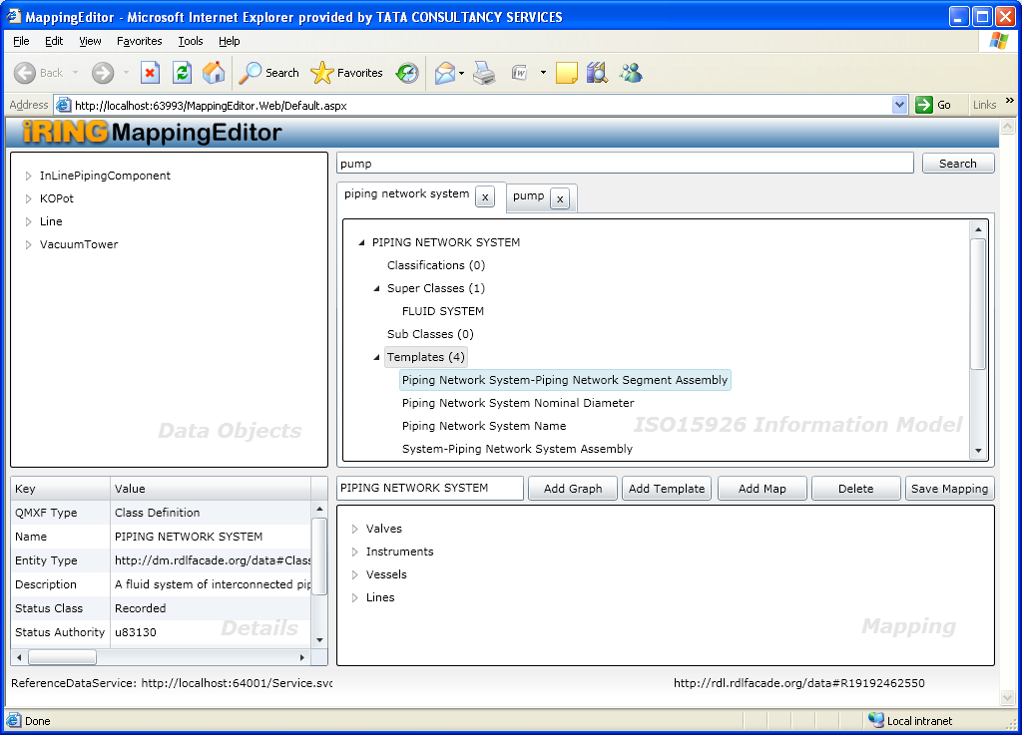

Mapping process

Following are the steps for Mapping Process
- Give any search criterion in search field in Information Model, Based on search criterion; the information model pane displays results

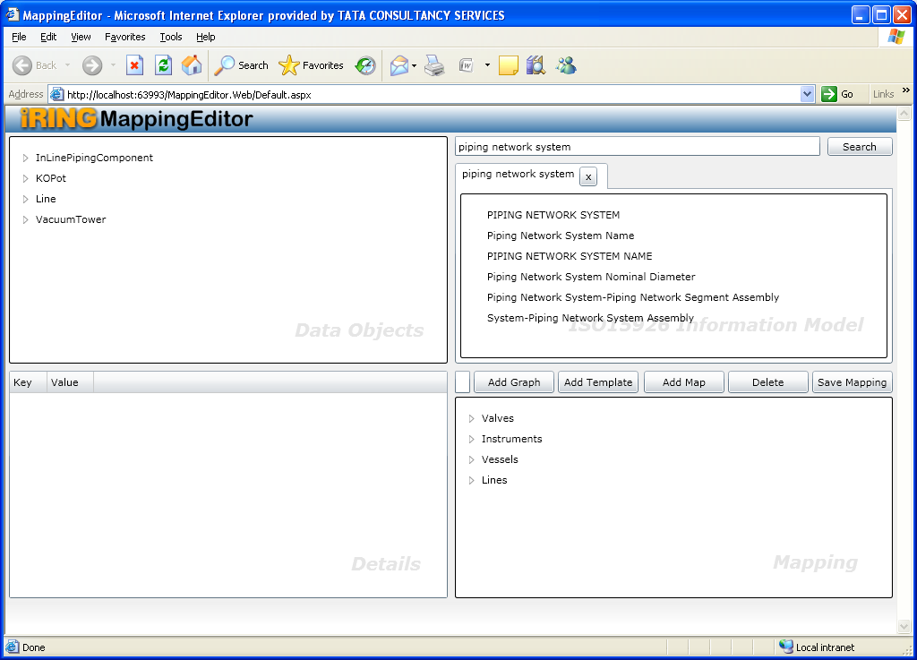

- Now perform following steps for mapping legacy system data objects to a class in ISO 15926
  - Select Piping network system from Information Model,
  - Provide the graphname in textbox in Mapping pane,
  - Select identifier from Data objects pane

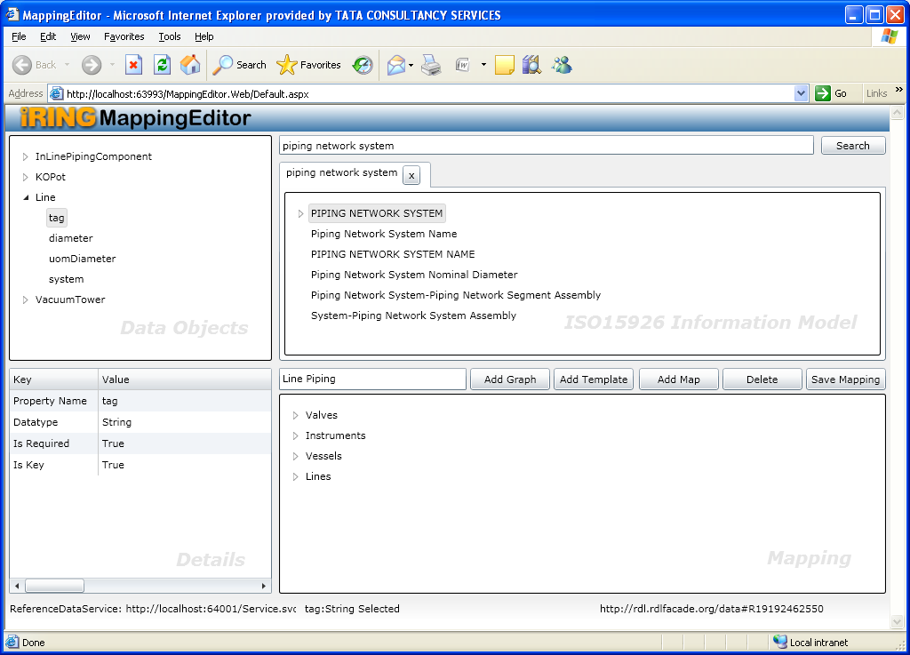

  - Click Add Graph. Graph will be added to Mapping.xml.
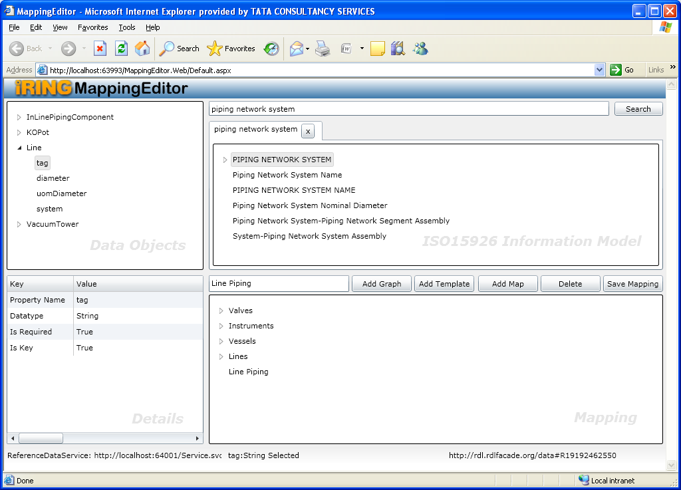

- Perform following steps for adding a template to graph in Mapping pane
  - Go to templates, select a template from Information Model,
  - Select graphmap from mapping, click Add template
The role - identifier under template will appear as unmapped
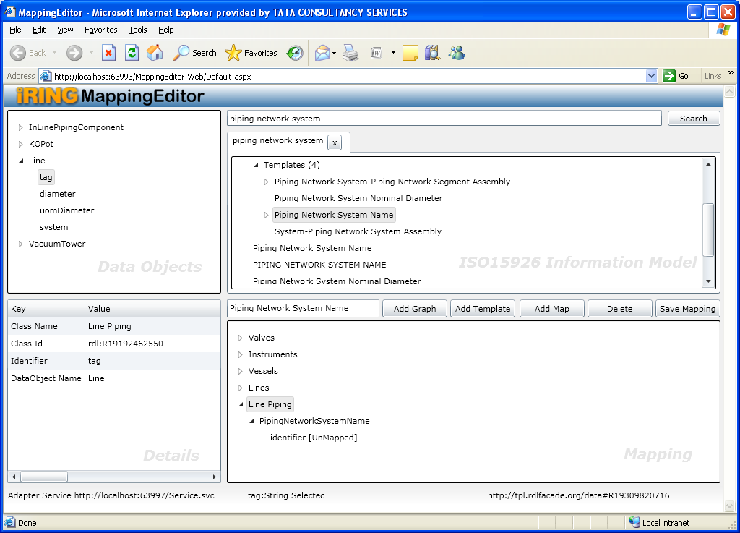

- Now we need to map it. Perform the following steps
  - Select role from Mapping, select property from data objects and click Add map
Unmapped will be removed.

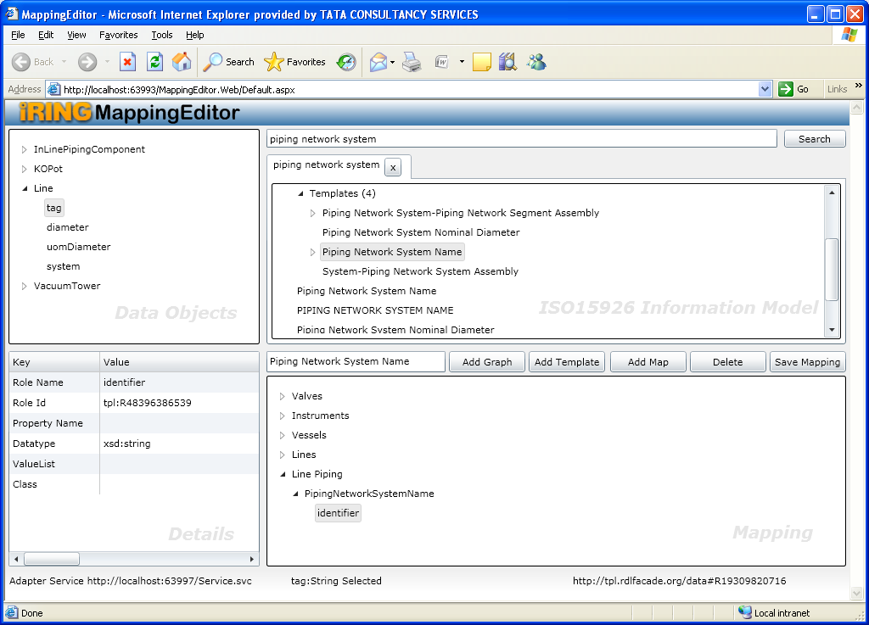

- Similarly another template can be added to mapped class in Mapping.xml

  - Select a template from Information Model and graphmap from mapping

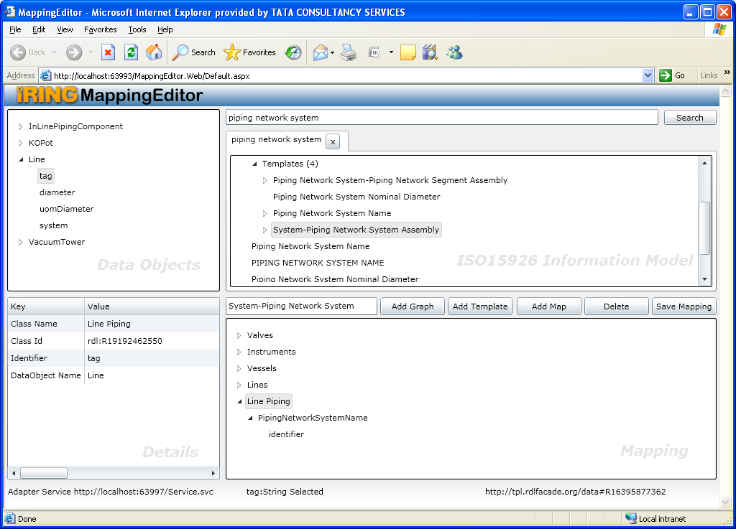

  - Click Add template.
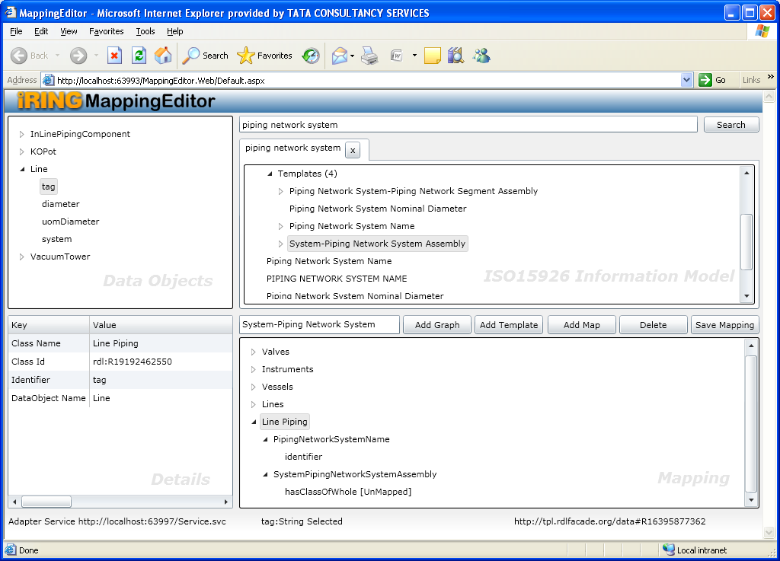

  - Select role hasClassofWhole from mapping. As it is a relationship template, so we will map it to class – SYSTEM in Information Model pane with system selected as identifier in Data Objects pane by clicking Add Map
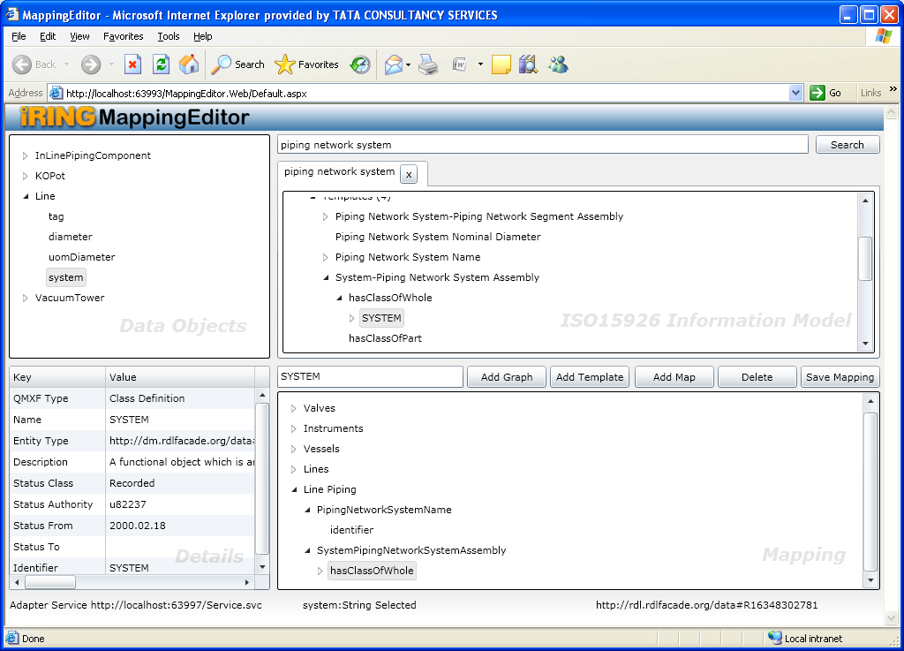

  - Add template System Name under System
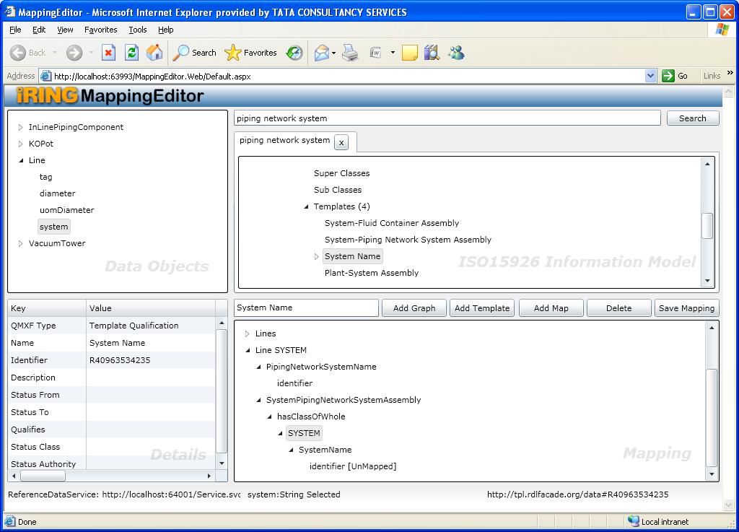

  - Select role – identifier in Mapping pane and map it to property system in data objects pane

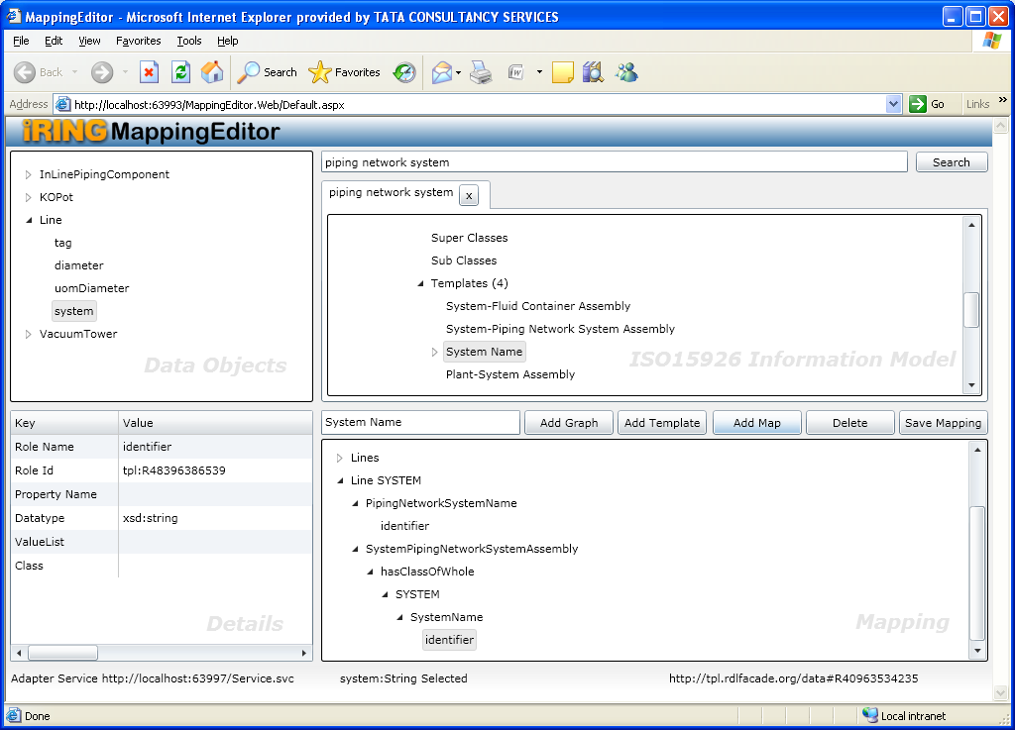

Now mapping is done. Click on Save mapping

Screen Shot TO BE ADDED

